🌿 LSEBN Green Teams Sustainability Newsletter
Special Edition – November 2025: Burns Services Sustainability Highlights

🗣️ A Message from Nicole Lee – Leading the Way in Sustainable Burns Care
As we close the year, I’m proud to see how far our burns services have come in embedding sustainability into daily practice. Across the UK — and internationally through BBA, ANZBA, EBA, and Türkiye — we’re proving that small changes can make a big impact.
From reducing red bag waste and switching to washable theatre caps, to rethinking patient travel and single-use plastics, each action brings us closer to a greener future. It’s also been inspiring to see that many of our suppliers are now striving toward net-zero — showing that sustainability truly is a shared mission.
The work of our Green Teams shows what’s possible when innovation, care, and environmental responsibility come together. Thank you to everyone who’s part of this journey. Together, we’re transforming burns care — for people and for the planet.
— Nicole Lee, LSEBN Burns Network Manager and Green Teams Lead
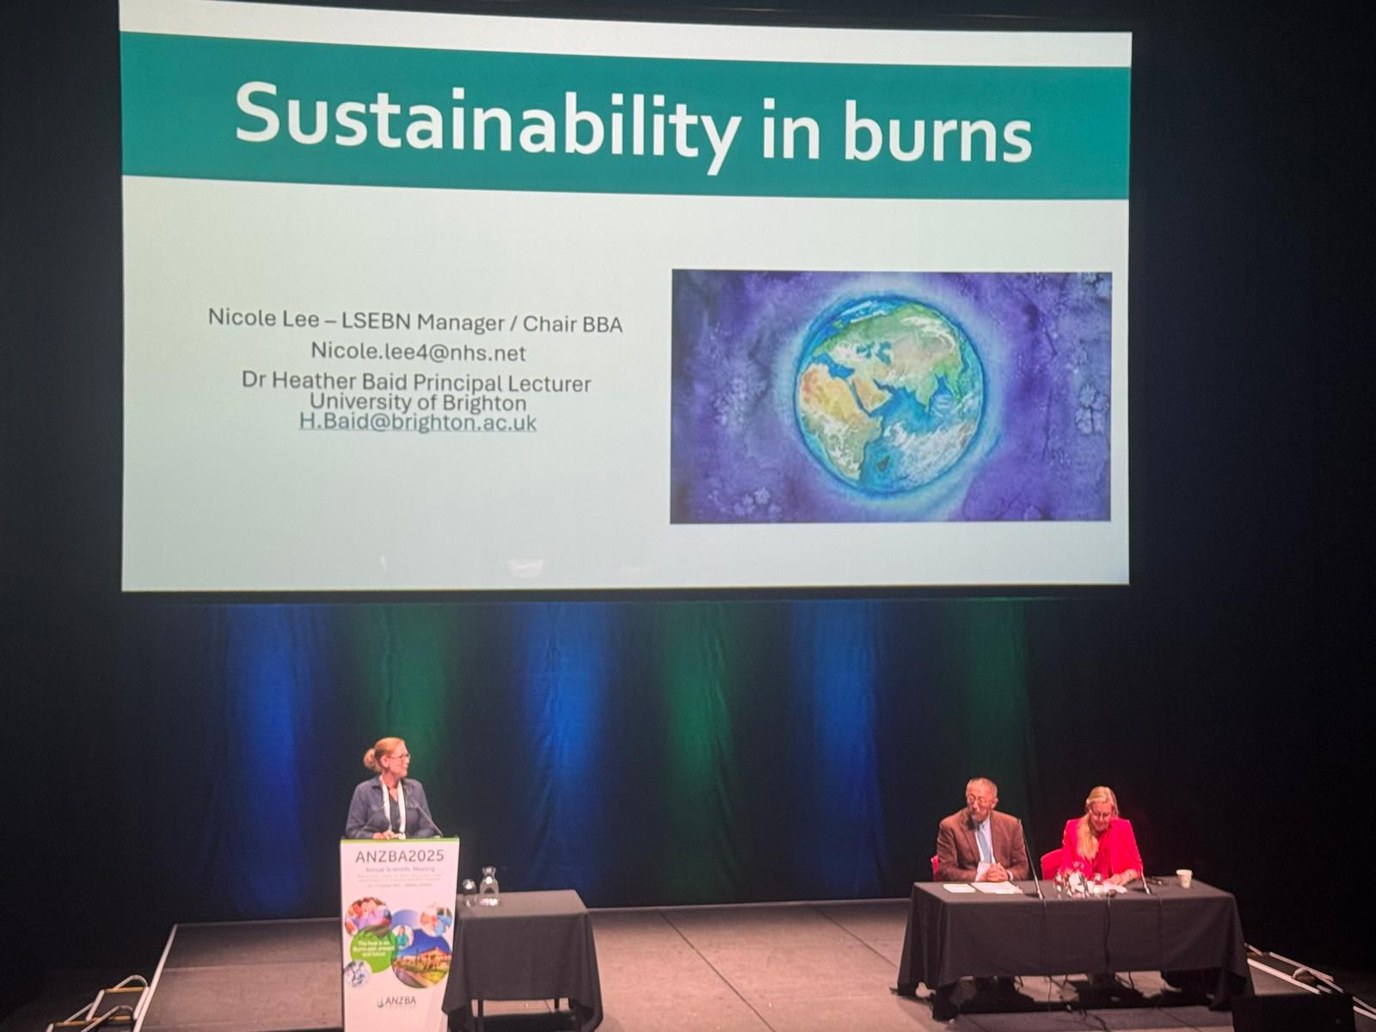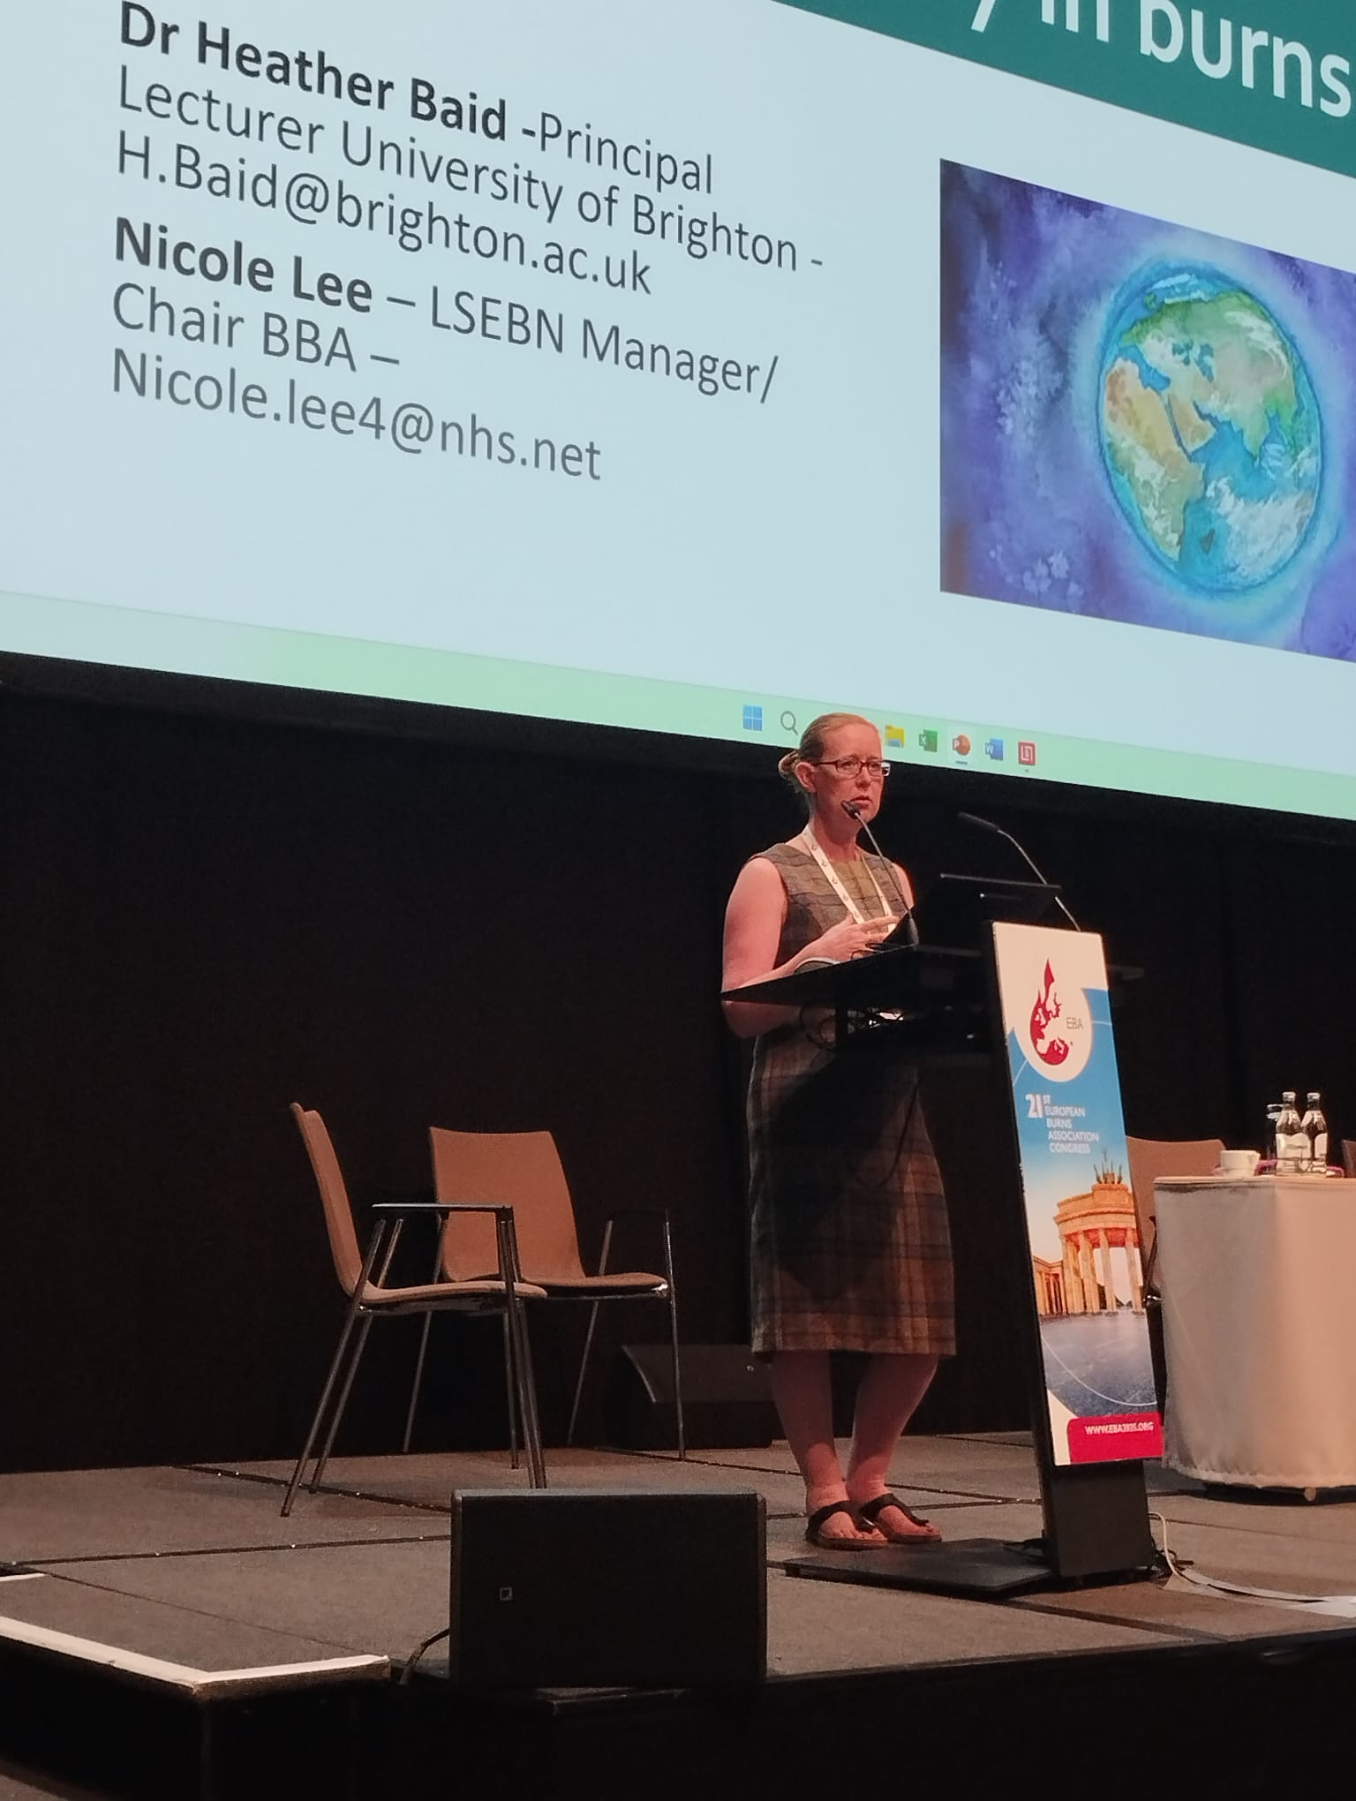
🎯 Our 2025 Sustainability Highlights
• Waste Audits
Increasing recycling capability across services and reducing incineration costs by minimising red bag waste. Chelsea team noted 41% waste in red bags was incorrectly disposed of.
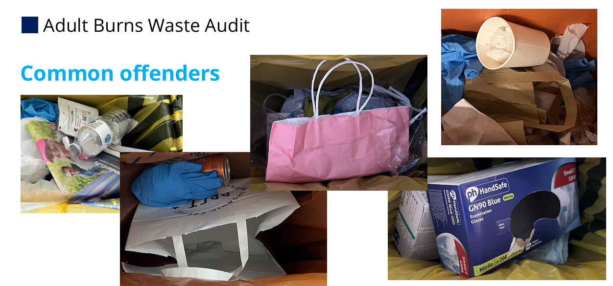
• Improved Waste Bin Stickers – Sebastian Dunne (Chelsea)
Helping staff easily identify what goes where — improving waste segregation and confidence.
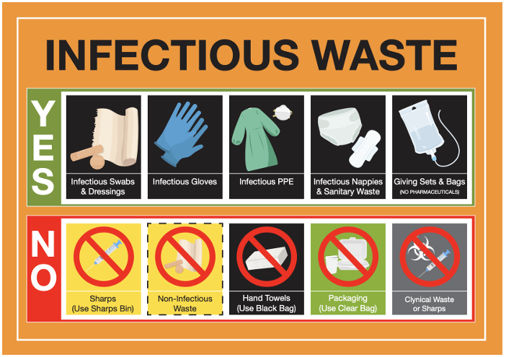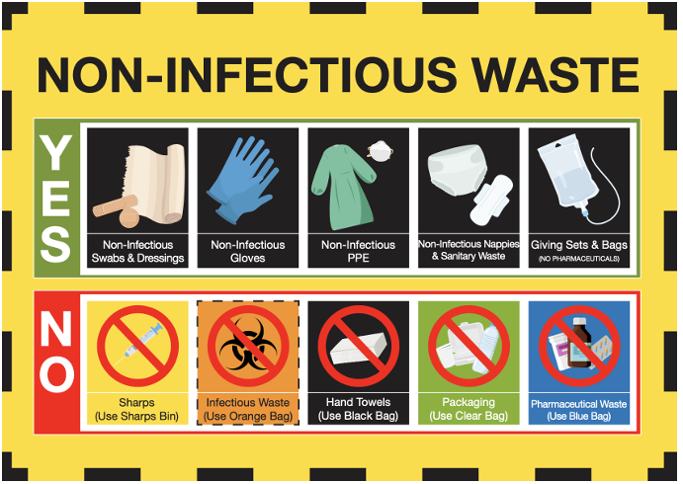
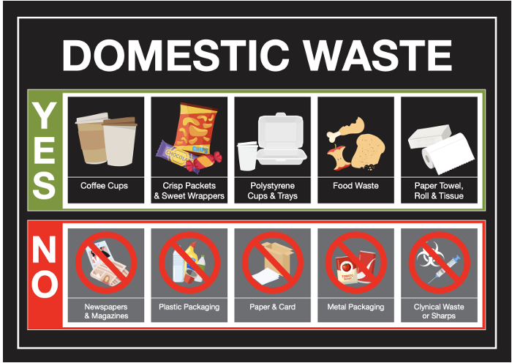
• Chelsea Team – Sustainable Outpatients Michelina Burke (Chelsea)
Transitioning from plastic to paper bags in burns outpatient areas for patient dressings. Introduction of paperless check in process reducing paper waste
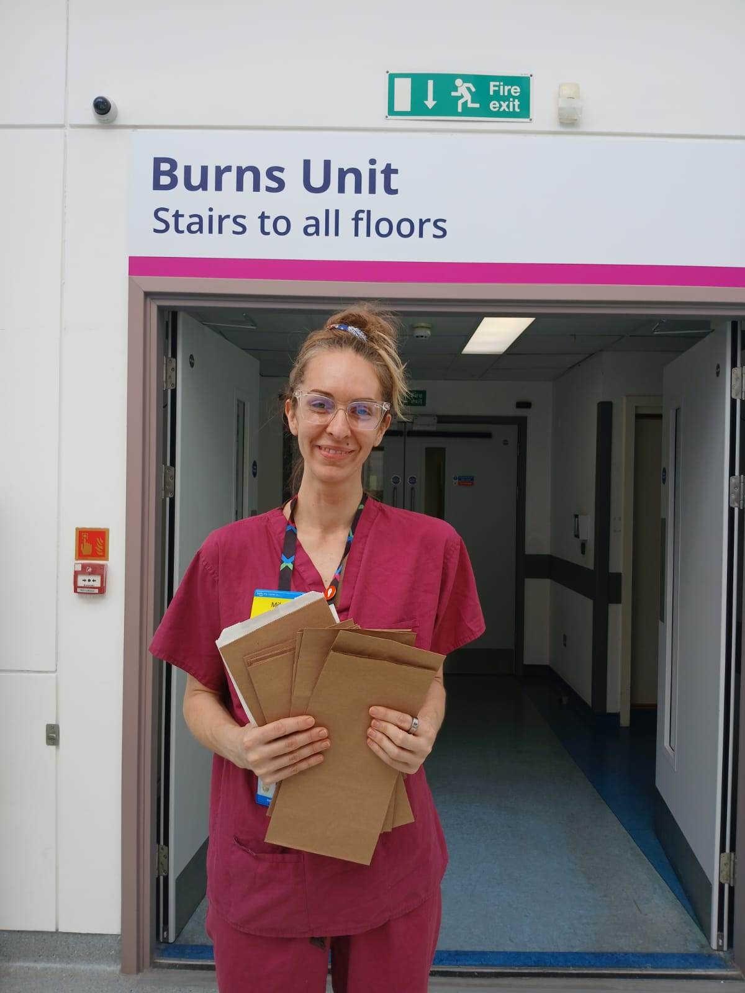
• Broomfield Team – Washable Theatre Caps
After adding sustainability to their monthly clinical services meeting this enable the full MDT to share ideas leading to Replacing disposable theatre caps with washable alternatives to cut waste.
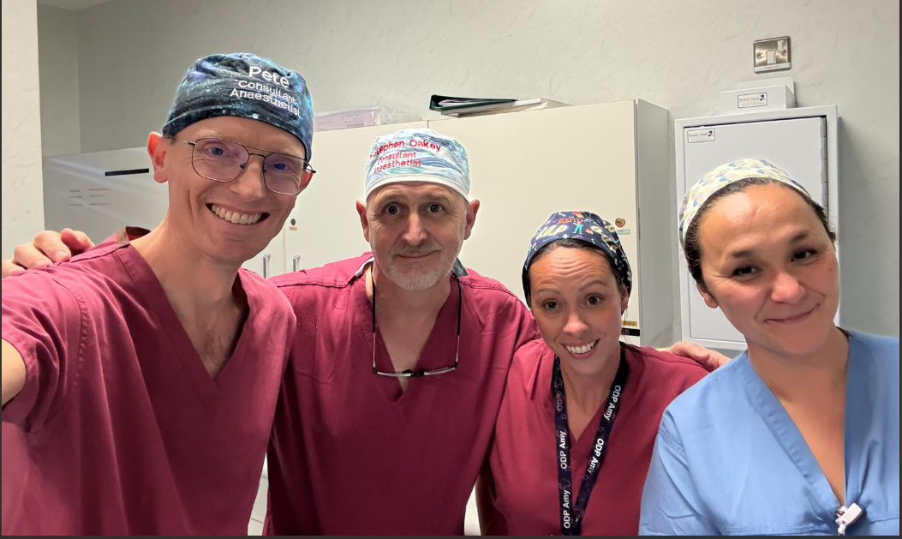
• Broomfield Burns Bus
Reducing patient travel by delivering care closer to home.
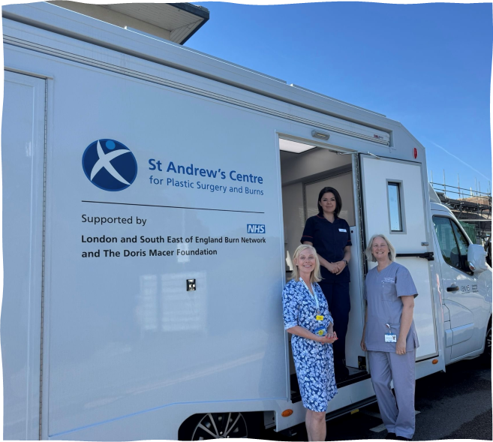

• Stoke Mandeville Team – Recycling & Engagement
Launching a fun “Spot the Difference” sustainability game to encourage participation.
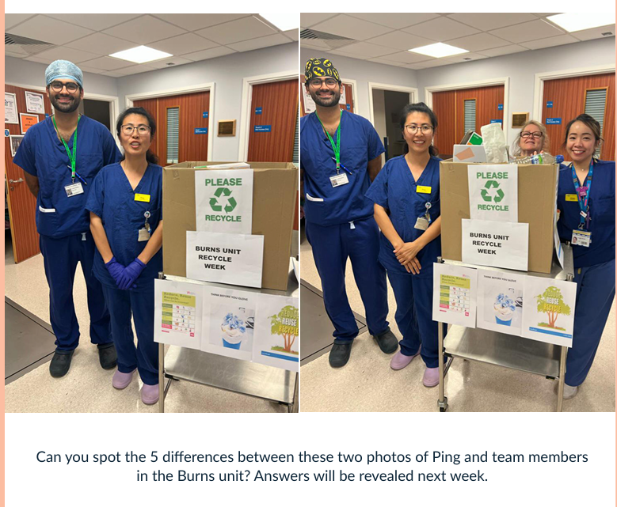
• Gloves Off Campaign
Supporting the national campaign to reduce unnecessary glove use and plastic waste.
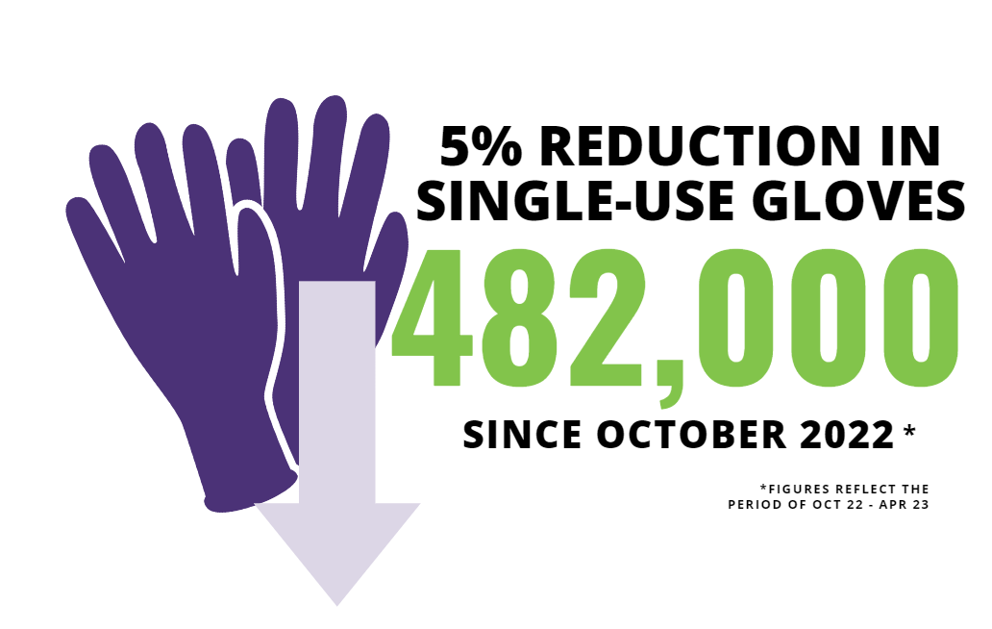

🌍 Looking Ahead
Contributing to the Burn Green Team Recipe Card for the upcoming National Critical Care Book.
Expanding research collaborations and sustainability reporting.
Continuing to reduce single-use plastics and carbon emissions across burns services.
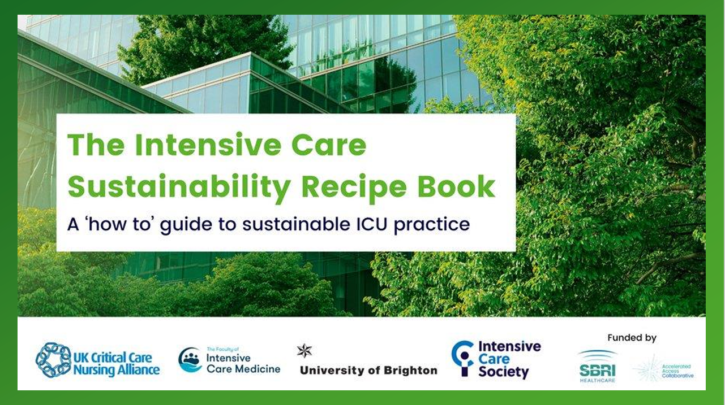
Green team Boards coming to every service to share your green team audits and innovations.

💌 Join the LSEBN Green Team!
Want to get involved or start your own sustainability innovation in your burn service?
Contact Nicole Lee at nicole.lee4@nhs.net
Let’s keep driving positive change together for a greener future in burns care.

